

Armada Connect - Enterprise ASSET monitoring & Management platform



March 24, 2025

ARMADA

SAN FRANCISCO, CALIFORNIA

**T**

**able of Contents**

1 Executive Summary 1

1.1 Key Benefits 2

2 Highlighted Features 0

2.1 Commander Portal - Single pane of glass 0

2.1.1 Fleet Map 0

2.1.2 Map Key 0

2.1.3 Connectivity 1

2.1.4 Router Settings 3

2.1.5 Asset Filtering 4

2.1.6 Global Asset Search 5

2.1.7 Starlink Alert Notifications with User Settings Page 5

2.2 Role-Based Access Control (RBAC) 8

2.2.1 Organizations and Accounts 9

2.2.2 Multi-Account Fleetmap 11

2.2.3 Assigning Roles to Users 12

2.2.4 User Roles FAQ 14

2.3 Audit Logs 15

2.3.1 Audit Logs FAQ 15

2.4 Data Consumption Management 16

2.4.1 Pooled Data Plans 17

2.4.2 Managing Pooled Data Plans 17

2.4.3 Case Study of an Existing US Based Customer 18

2.4.4 Benefits of Armada Consumption Management 19

2.5 Group based assets 19

2.5.1 Assets tab 20

2.5.2 Groups tab 23

2.5.3 Fleet Map - Filter by Groups 26

2.5.4 Groups - FAQ 26

2.5.5 Asset Groups Benefit 27

2.5.6 Asset Download 28

2.6 Actionable Alerts and Observability 28

2.6.1 Log Retention 29

2.6.2 Benefits of Commander Connect 29

2.7 Advanced Networking / Bonding 29

2.8 Artificial Intelligence-powered Tools 30

2.8.1 AI Assistant - LLM Conversational Agent 30

2.9 Integrated Support 31

2.10 Armada Marketplace 32

2.11 Drones 33

2.11.1 Skydio Drones 33

2.12 SD-WAN 35

2.12.1 Fleet Map view of SDWAN Devices 35

2.12.2 List view of SDWAN Devices 36

2.12.3 SDWAN Device Details view 37

# Executive Summary

Commander Connect is an Enterprise Monitoring and Management system for Connected Assets. It is the cornerstone of Armada's global management suite, offering a centralized asset management platform for both customers and partners. Its primary function is to provide access to internet connectivity and facilitate remote (or local) management of connected Starlink terminals and bandwidth plans. The platform's design provides users with comprehensive experience, simplifying intricate remote asset management tasks through a "single pane of glass."

Video overview of Commander Connect:

* [https://doc](https://docsend.com/v/c7kkg/commander_connect_demo_june_2024_brief)send.com/v/c7kkg/commander_connect_demo_june_2024_brief
* <https://docsend.com/v/c7kkg/commander_connect_demo_june_2024_extended>

## Key Benefits

Connect provides distinct advantages, and here is an overall summary of benefits that are detailed in the following pages of this document.

* **Advanced Security / Role Based Access Control and Accounts**
  + SSO / Native Identity Provider (IdP) Connection enables customers to centralize security and access policies under its existing IT security policies.
  + Role Based Access Control (RBAC) enables customers to create different roles with access levels to better control access policies (read only access, full admin etc.)
  + Support for multiple accounts per-org allows for separation of assets and users by business unit or other organizational requirements.
  + Asset and Group Management enables customers to assign terminals asset owners (administrators) to manage and receive alerts
  + Support for multiple subdomains in a single SSO configuration, streamlining the login process for users across different domains.
* **Single pane of glass for all your Connected Assets**
  + Command Connect provides a one stop view of all your connected assets. Connect provides an aggregated view of assets along with an ability to drill into additional details for each of the assets.
* **Overage Monitor and Overall Cost Reduction**
  + Armada can provide a monthly bandwidth allotment, which will help lower costs across stores by sharing monthly data, instead of each individual terminal having limited or too much individual data. This will significantly reduce monthly costs
  + Armada provides analytics and alerts for monthly and daily data consumption per terminal and fleet-wide, enabling better visibility and planning for consumption to reduce costs/consumption
* **Actionable Alerts and Observability:** Armada’s alerts and notifications are architected to be useful for technical support and actionable to help reduce cost and time to solve any issues pertaining to Starlink and IoT operations.
* **Advanced Networking / Bonding:** Armada supports Starlink bonding, which combines multiple Starlink connections into one strong virtual connection, providing higher bandwidth for data intensive upload/backhaul or downloading speeds
* **Artificial Intelligence-powered Predictive Insights and Foresights:** Armada’s in-house AI expertise provides reporting powered by AI, which provides detailed analytics and predictive insights to further reduce costs and keep your Starlink investment performing optimally well into the future.

# Highlighted Features

## Commander Portal - Single pane of glass

### Fleet Map

The Fleet Map, which is the centerpiece of the Commander interface, shows a live geographic overview of stationary and mobile assets, such as satellite terminals, galleons, sensors, robots, drones, vehicles, etc.

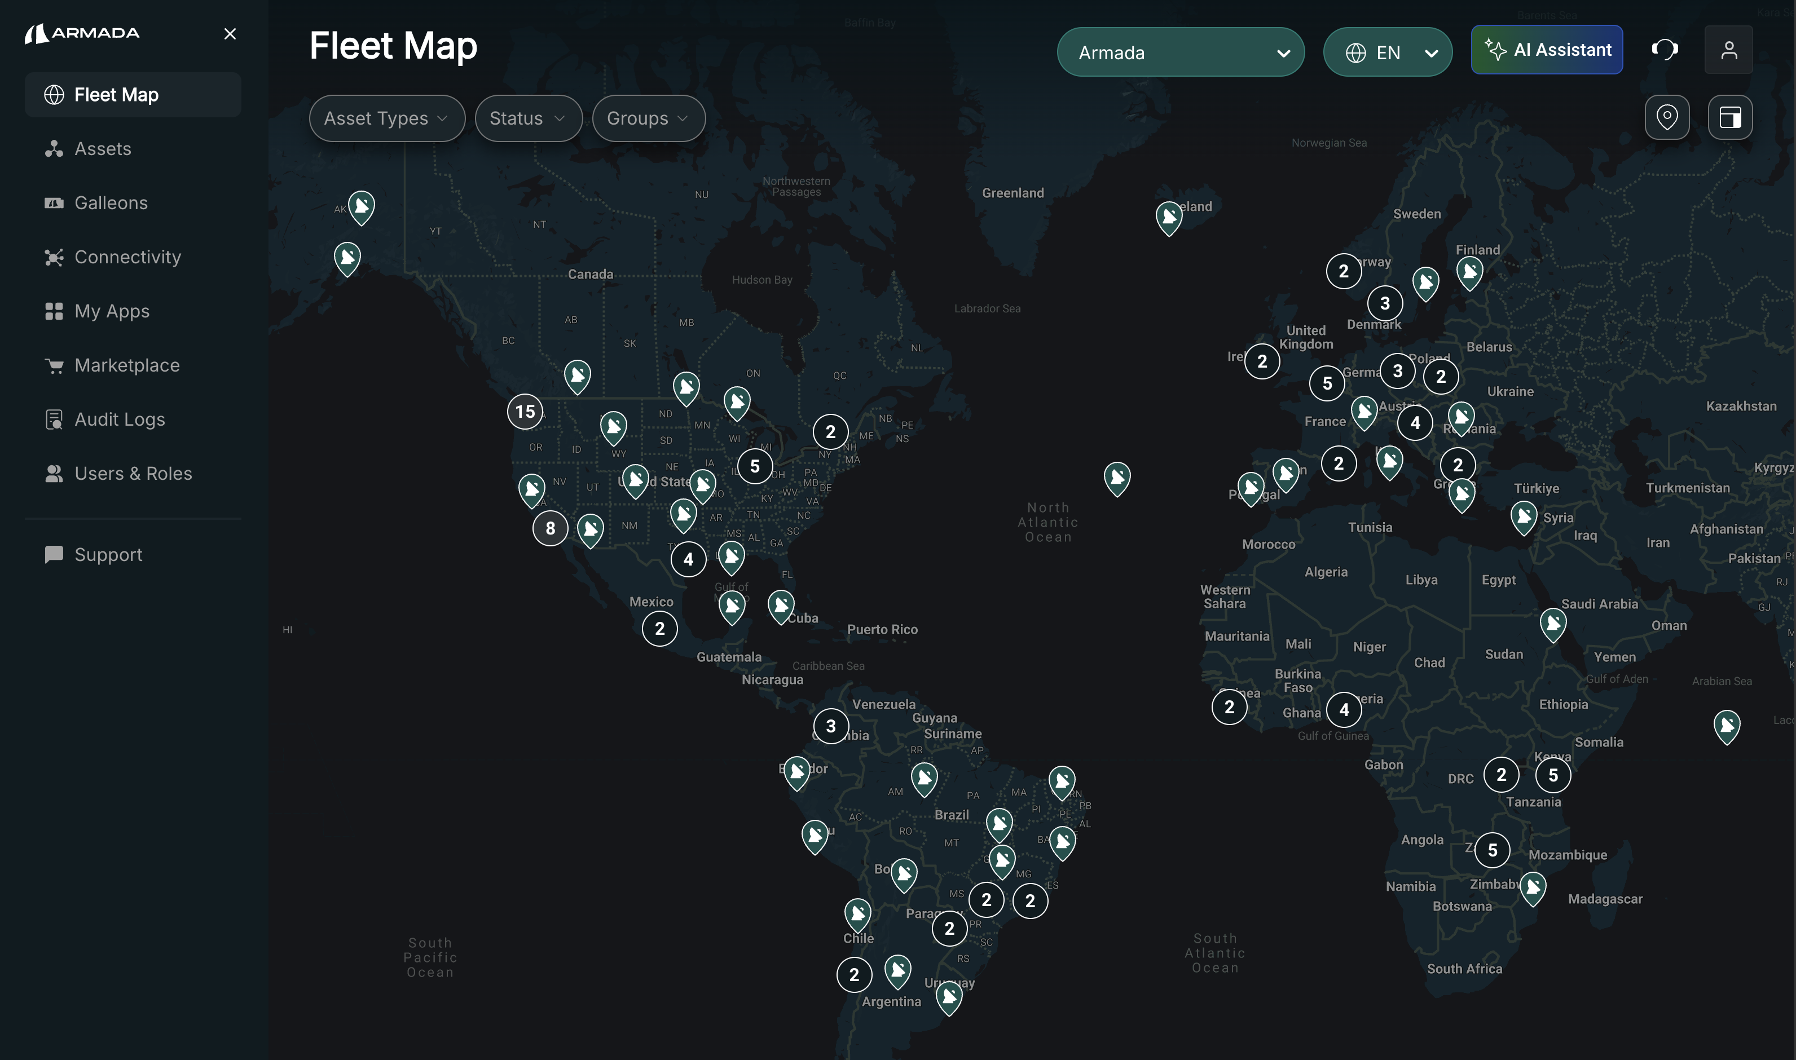Figure 2‑: Fleet Map Overview, providing a complete view of all assets and their operations

### Map Key

The user experience is paramount to Armada and is the basis for all our design experiences. You’ll notice these design elements sprinkled throughout the Connect platform and below is a sample experience of Icons for ease of use and readability.

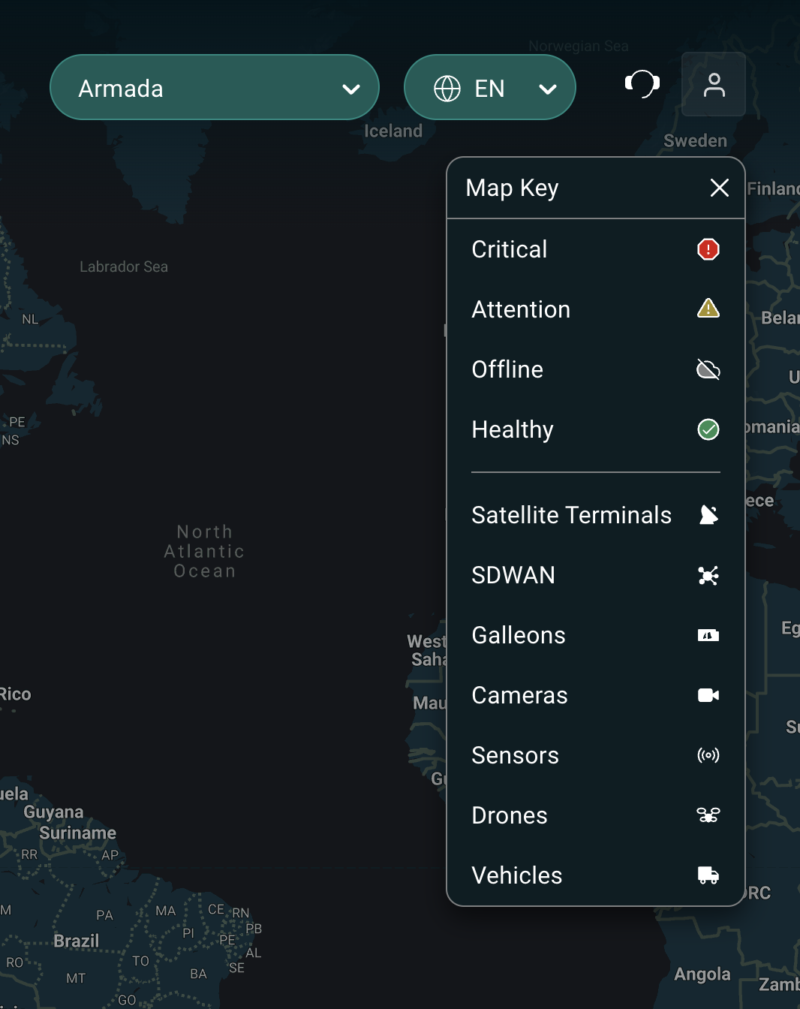

### Connectivity

A high-level overview of your asset’s active alerts, data usage over time, and a list of your assets. Dive into the Network Statistics or Monitoring and Alerts tabs for further information about your fleet performance.

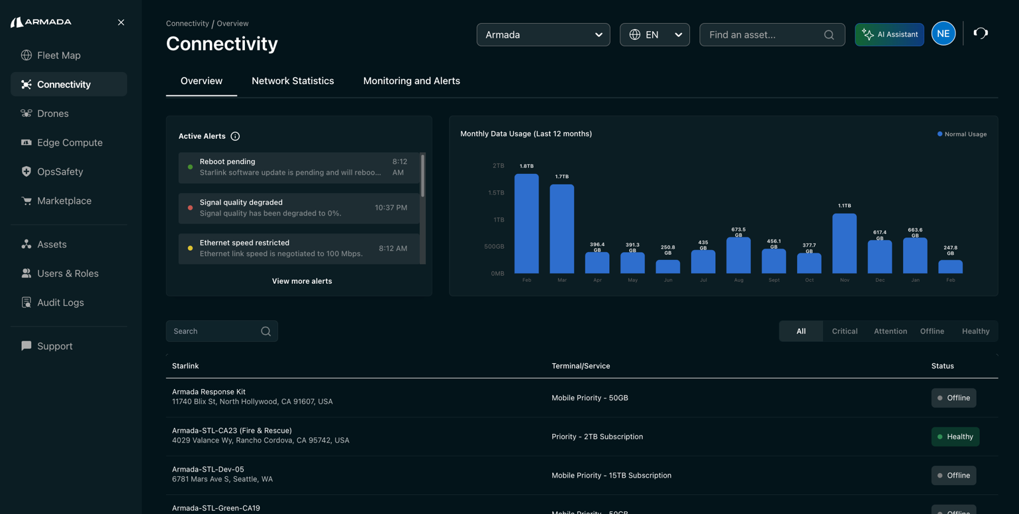

Connectivity shows a high-level overview of your asset performance

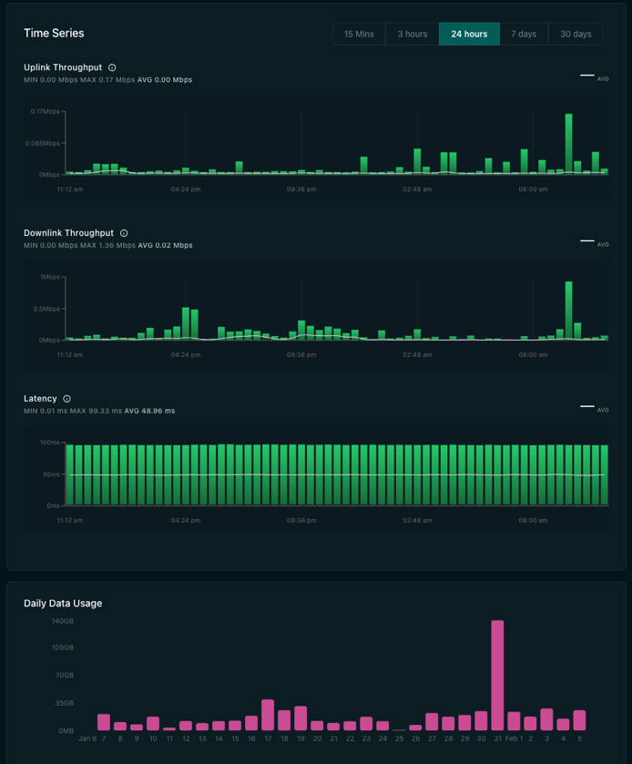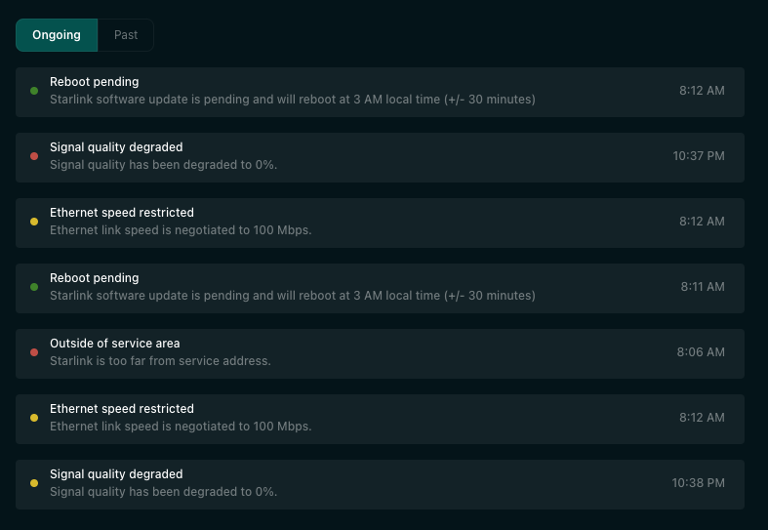

Dive into your time-series network stats and your ongoing or past alerts

### Router Settings

Explore the 'Routers' tab under Connectivity > *Asset* > Routers, where you'll find everything you need about your Starlink Router: router name, ID, hardware version, and much more at a glance.

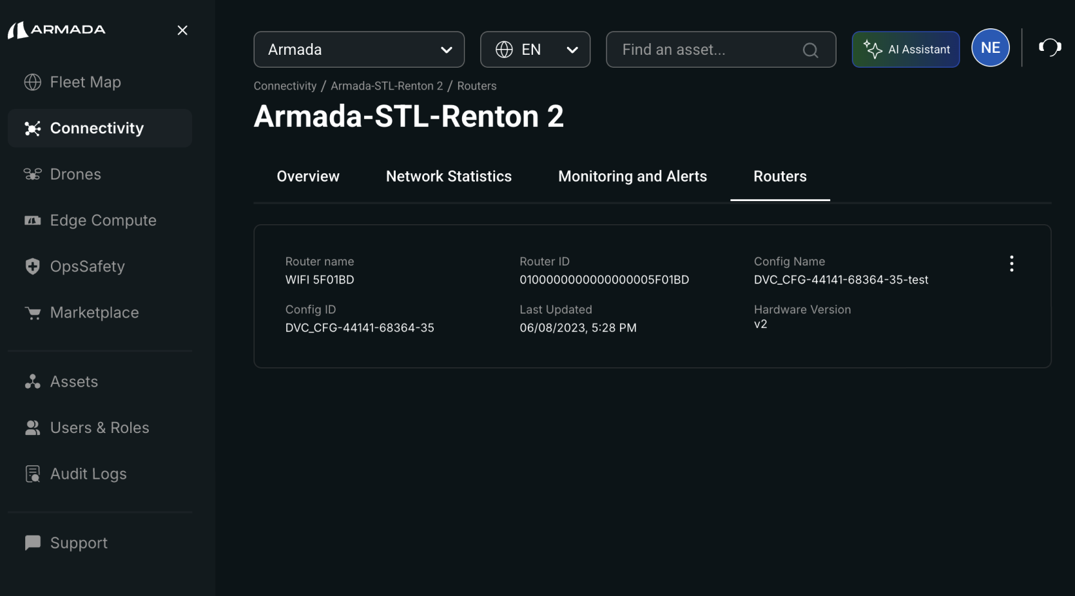

Update your Wi-Fi name and password directly from the Router Settings page. Apply changes to a single router or synchronize updates across your entire network configuration.

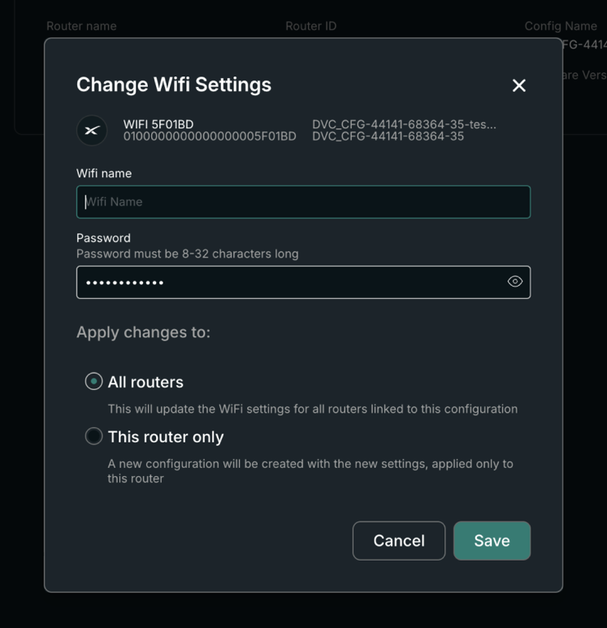

Apply changes to a single router or synchronize updates across your entire network configuration.

### Asset Filtering

The Fleet Map provides a convenient feature to filter by the type of Assets and status or health condition of the assets.

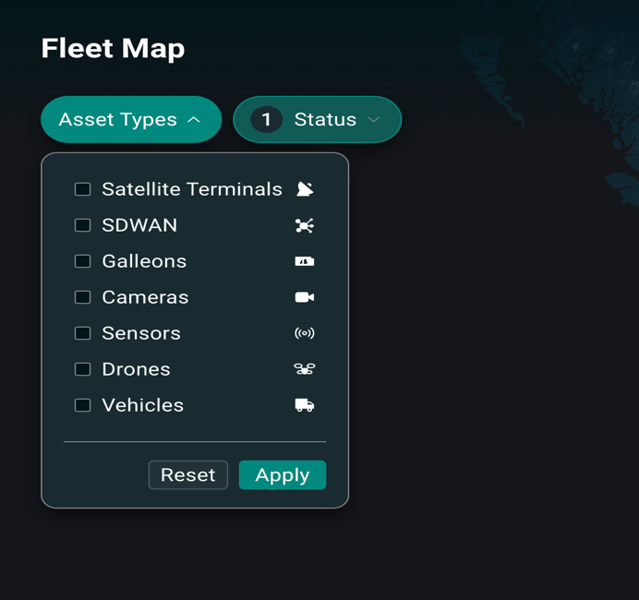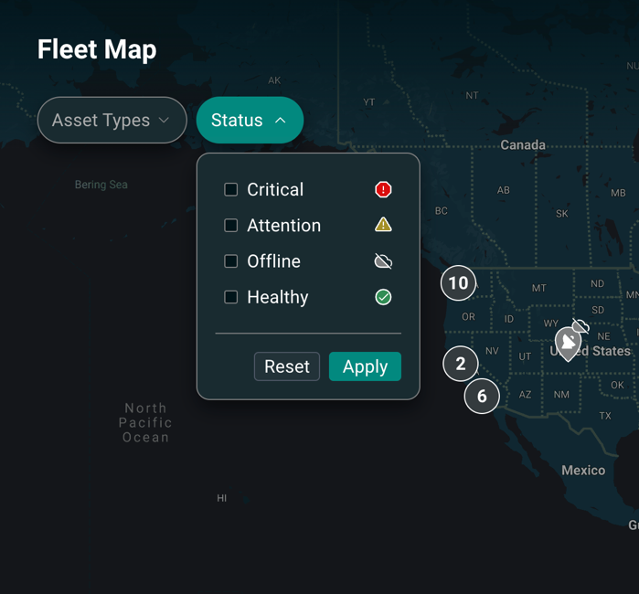

### Global Asset Search

The enhanced Asset Search functionality is designed to provide an efficient, precise, and interactive search experience across various asset types within Commander Connect. Asset name, description, address, serial number, kit number, and various other attributes are available for querying through a global search box in the header across all console pages. More advanced search and filtering capabilities are available on the Assets page.

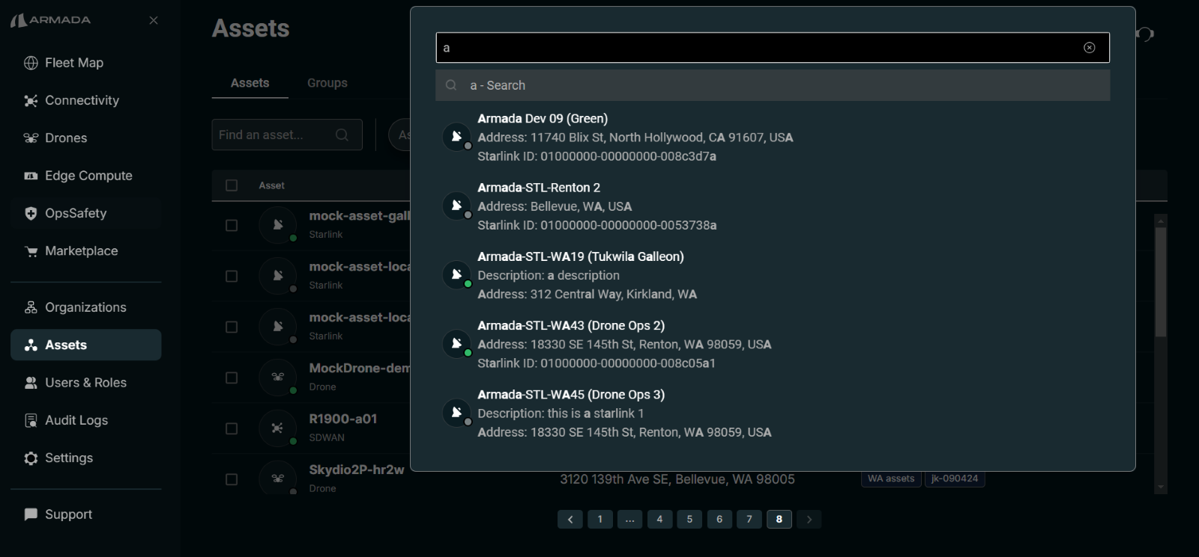

Photo: Global Asset Search UI is available at the top of Commander and the Assets Search Page.

### Starlink Alert Notifications with User Settings Page

**Alert categories**: Alerts are grouped into categories including hardware, performance, service, and terminal. Opt into all or any of the alerts you’d like to monitor. and

**Real-time notifications**: Emails are sent as soon as alert conditions are met. You’ll be able to stay informed and react to the conditions of your Starlink assets.

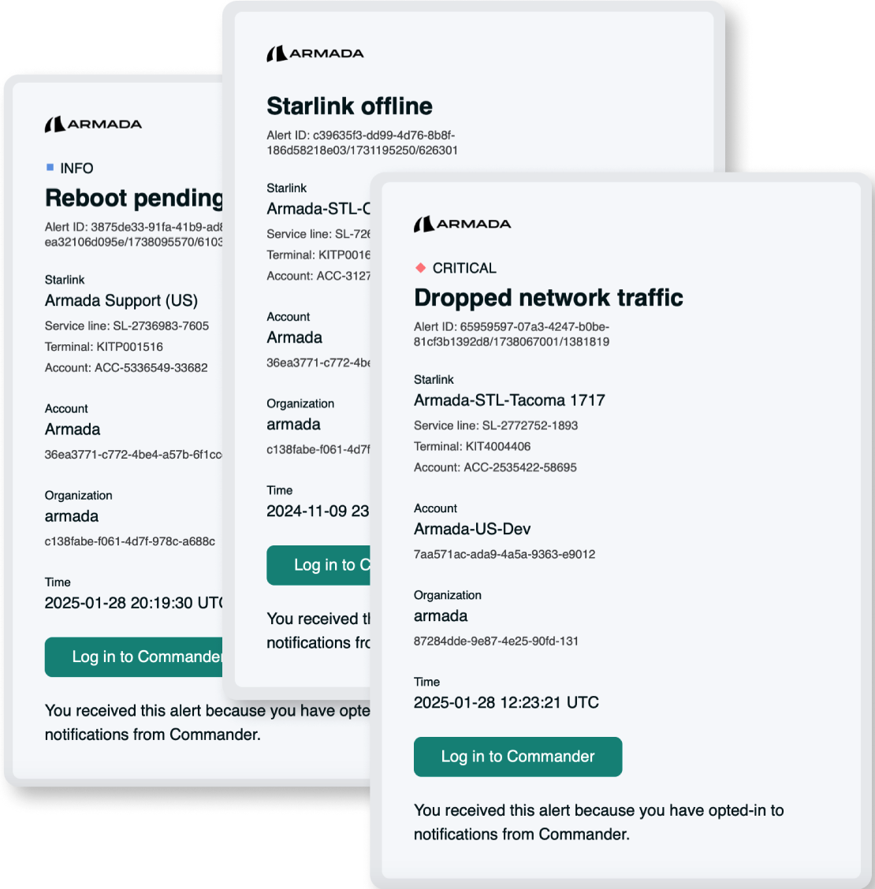

Alert Emails show specific details about your ongoing alerts, with a link to Commander.

Set your email alert preferences: Navigate to Connectivity → Notification Settings to enable email alerts whenever specific conditions are met.

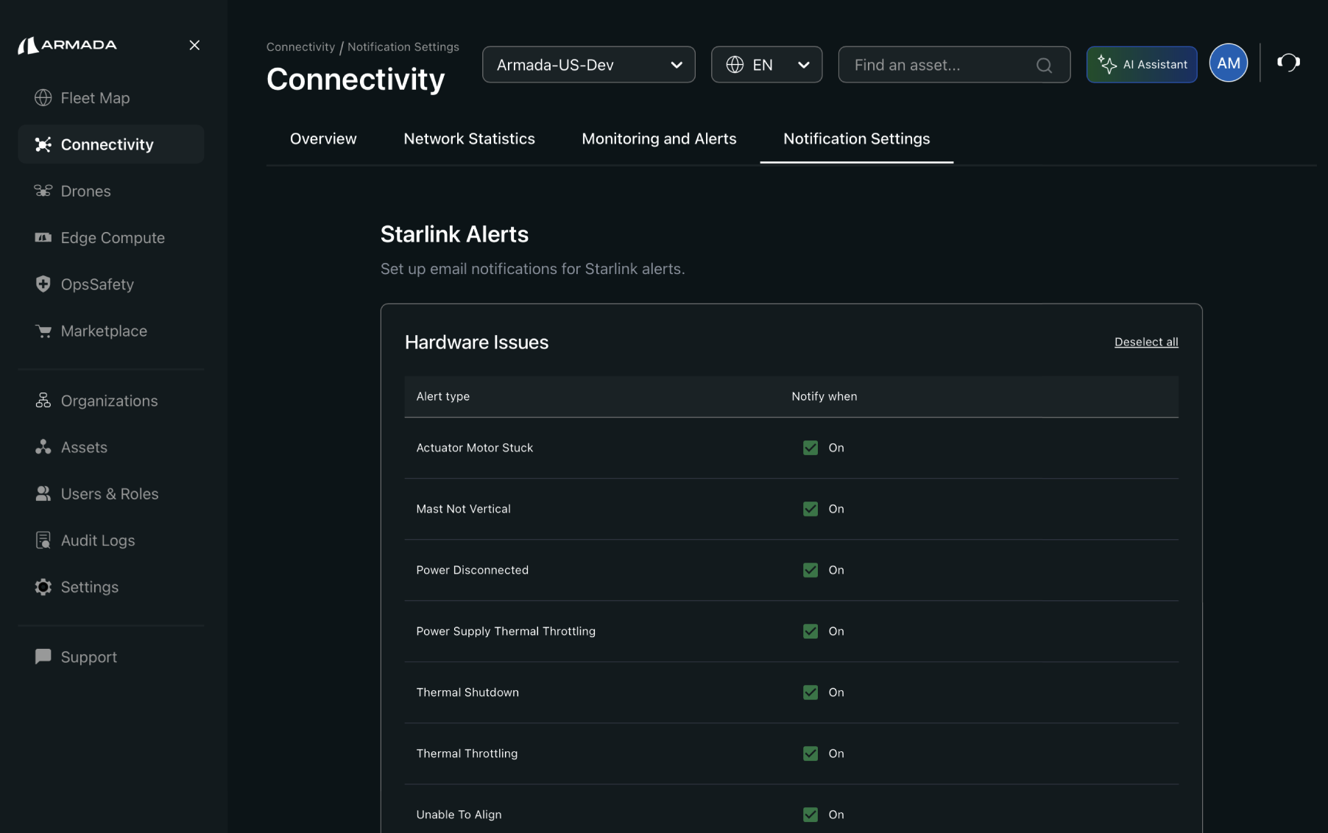

The notification settings page.

**Alerts FAQ:**  
What alert notifications will be enabled by default?

Notifications are disabled by default. Please log in to Commander and set your notification settings for the alerts you’d like to monitor.   
  
Can I setup custom alerts or thresholds?

Not yet. If there’s a specific alert you need, email us at feedback@armada.ai so we can track your request.  
  
What if an alert severity changes?

You’ll be notified at each new threshold: once for warning and once for critical. You won’t receive a second warning notification when alerts downgrade.  
  
How quickly will I be notified?

Our system sends emails as soon as alert conditions are met. Delivery speed depends on your email provider, but most users get them in under a minute.

## Role-Based Access Control (RBAC)

RBAC is the ability to assign roles to users and restrict them from performing certain actions within Commander. Users can perform tasks ranging from asset management, user management, overseeing financial operations, all tailored to their specific roles - users are granted access to exactly what they need to perform their job function but no more. RBAC strengthens security and operational efficiency by ensuring users have appropriate access levels.

The following roles can be granted to users:

* **Technical Viewer**: Read-only access to the Connect portal. Users can view details of Starlink terminals and other assets but cannot change any aspects of assets and groups.
* **Technical Admin**: Used for managing technical resources, such as Starlink service plans and Asset Groups.
  + **Asset Groups**: Create, edit, delete groups. Add/remove assets to groups.
  + **Starlink**: Change service line name and address, change service plan, opt in/out of priority data, cancel/pause/resume service.
* **Identity Admin**: Users with this role can add and remove users to the account and change user roles.
* **Auditor**: Users with this permission will see a new side-navigation option "Audit Logs" which allows you to view, filter, and download auditable events that have occurred within the account.
* **Billing Admin**
  + Initially assigned to your identity admin.
  + Holds the highest level of permissions for billing-related activities.
  + Can manage payment methods and pay invoices.
  + Ability to add other users to the Purchaser role.
  + Has full access to all billing and purchasing functions.
* **Purchaser**
  + Can use the Billing Account to make purchases.
  + Able to view orders placed by themselves.
  + Cannot view or modify payment instrument details.

Users and their role assignments are managed on a per-account basis by Identity Admins through the Users & Roles tab, available in the left side nav for authorized users.

### Organizations and Accounts

Connect customers are represented through two entities in our system: Organization, and Account.

* **Organization** is the representation of the customer's company and includes details such as recognized domain names and email addresses ([person@example.com](mailto:person@example.com)). Authentication happens in the context of an Org.
* **Account** is a subscription to the Connect platform for the purpose of viewing and managing assets. Each account belongs to an organization, and organizations can have multiple accounts. Assets are managed in Accounts. Authorization typically happens in the context of an Account.

Most customers use Connect through a single Org and Account. When users log on, they access the default account associated with their org.

Large customers, however, can take advantage of our platform's support for multiple accounts associated with a single organization. This capability is often used to segregate assets and billing between org units, departments, etc. When users log on, they are presented with a prompt to choose an account to access. The same user might have different access levels (role assignments) in different accounts.

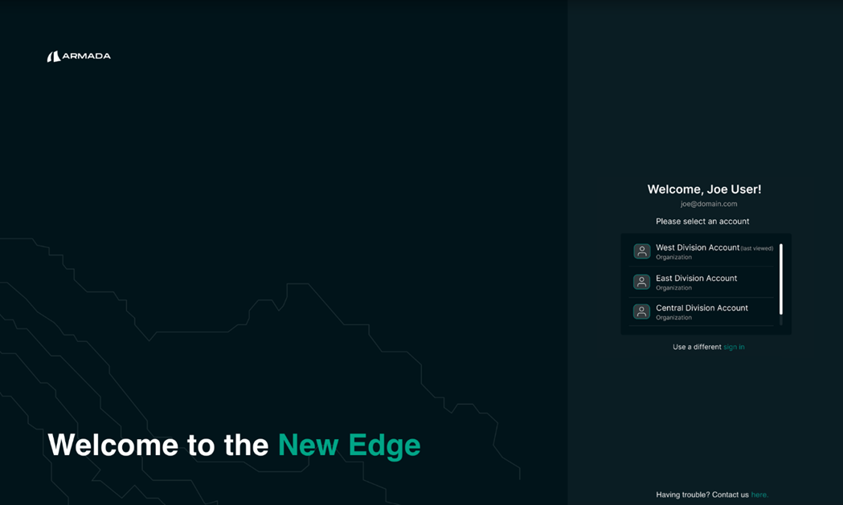*After authenticating, the user selects which account to manage.*

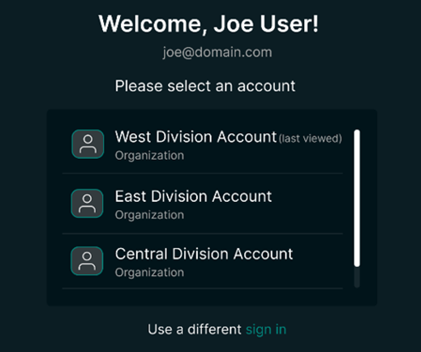

*After authenticating, user selects which account to manage.*

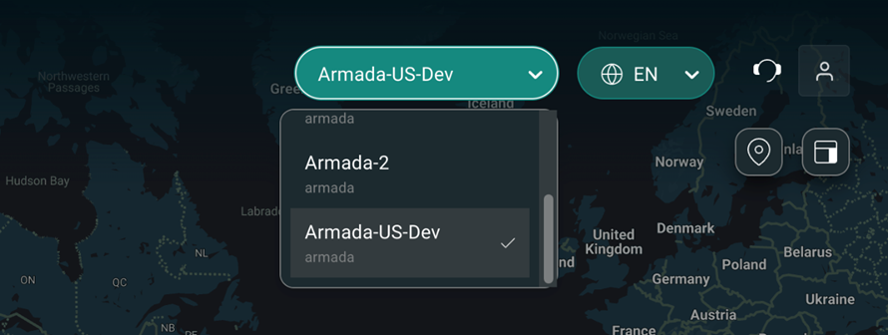

*User can quickly switch to other accounts after logging in, while interacting with the portal.*

### Multi-Account Fleetmap

Users with access to multiple accounts can now filter assets by account using a new "Accounts" multi-select filter, and view assets from multiple accounts side-by-side in the Global Fleet Map view.

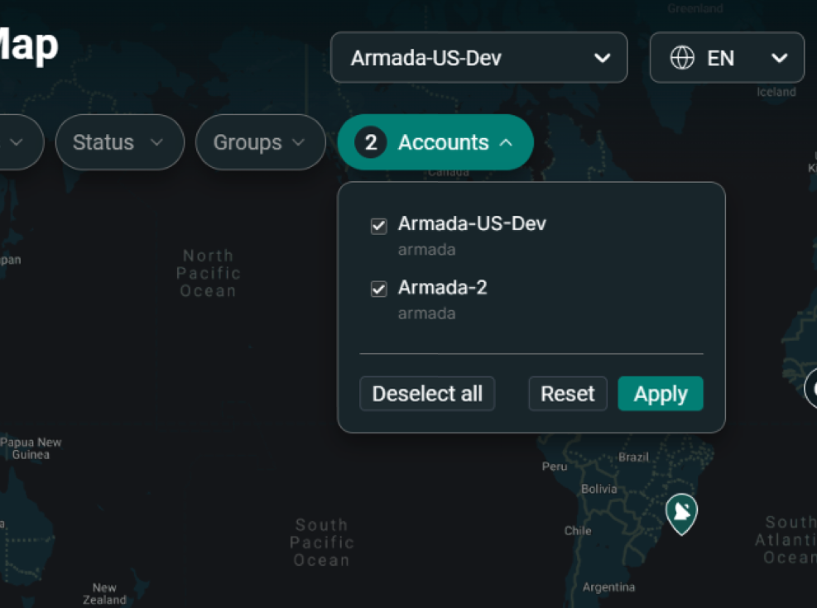

Assets from all selected accounts display collectively on the fleet map. Hover and click experiences indicate the associated account for each asset.

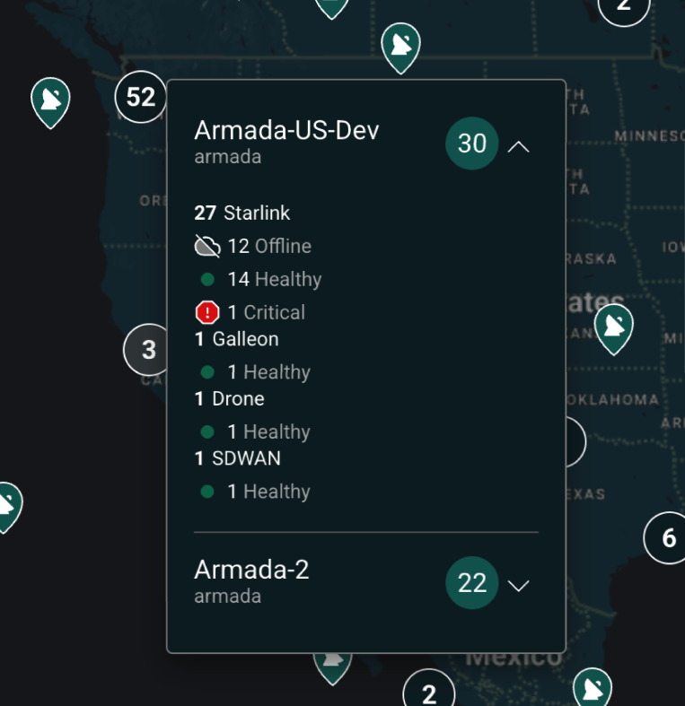

### Assigning Roles to Users

An **Identity Admin** can add other users to the account and assign or unassign roles through the **Users & Roles** module. Notes:

1. Role assignments are effective at the **account** level. So, for example, a single person, Joe, can have different roles in different accounts:

* [**joe@example.com**](mailto:joe@example.com)is **Technical Admin** for **Ops-West** account on **Example** org.
* [**joe@examples.com**](mailto:joe@examples.com)is **Technical Viewer** for **Ops-East** account on **Example** org.

2. Users from other organizations can also be given roles to accounts of other organizations. For example:

* [**jeff@networksolutions.com**](mailto:jeff@networksolutions.com)is **Technical Admin** for **Ops-West** account on **Example** org.

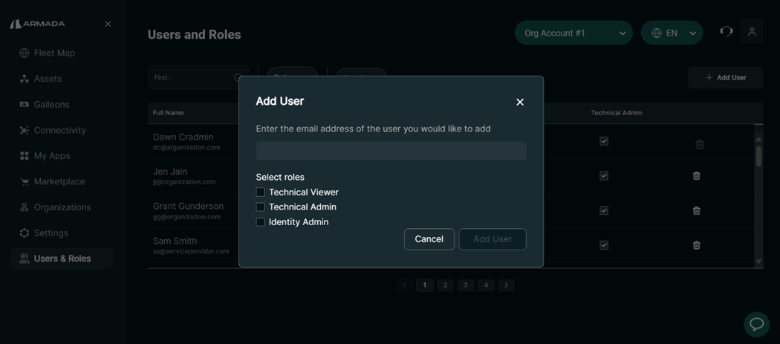*Identity Admin adds new users to this account and assigns roles.*

The table of Users and Roles clearly identifies which users have access to the current account. In this table, it's easy to identify what roles each user has. The Identity Admin can grant and remove role assignments by checking and unchecking the corresponding box in this matrix.

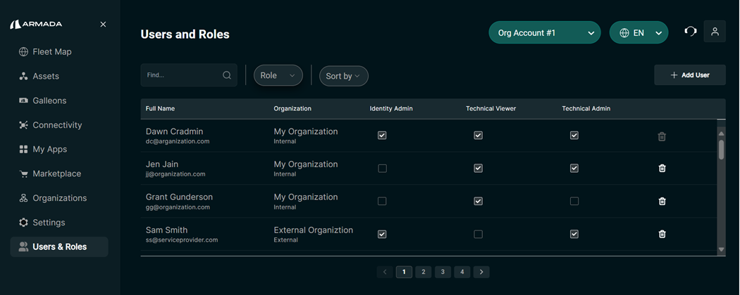*Identity Admin can assign and unassign roles or remove users from the account.*

### User Roles FAQ

**Q: Who are my users and what access do they have?**

With the initial rollout of RBAC, we have granted all available roles to every user in your accounts. We recommend that you review the list of users associated with your accounts and follow the "least privilege principle". Specifically, remove any users who no longer need to have access to your accounts, and unassign unnecessary roles from the remaining users. Each user should have the minimum level of access that is required for them to carry out their responsibilities. Make sure to restrict Identity Admin to one or few users in your organization whose job is to safeguard the safety and security of your Connect accounts. Identity Admin is a powerful role that can assign any role to a user, or to themselves.

**Q: Can I create custom roles?**

No. In this release, we're making "system-defined roles" available to our customers. Customer-defined roles are not supported in this release.

**Q: How quickly do changes take place when I add or remove users and assign or unassign roles?**

Changes take effect immediately.

**Q: Can I restrict access for a certain user to a certain asset group?**

No. Role assignments are effective at the Account level. Asset Groups are a construct within accounts. Role assignments at Asset Group level are not supported in this release.

**Q: Can I invite users from other organizations to manage my assets?**

Yes, cross-org role assignments are supported. Simply, enter the email address of a Connect user and specify their role assignments through the "Add User" dialog. The user you specify may be from your own organization or any other organization who has already been onboarded to the Connect platform.

**Q: I'm a Managed Service Provider (MSP); can I control my client's access to their Connect platform?**

Yes, make sure that you have Identity Admin role on your client's account, and adjust your client's role assignments as needed.

**Q: Why can't I remove myself as an Identity Admin?**

This restriction is in place to ensure that customers are not inadvertently locked out of their account. To remove yourself as an Identity Admin, grant this role to another user and then ask them to remove the role from your profile.

## Audit Logs

Users with the “Auditor” permission will see a side-navigation option "Audit Logs" which allows you to view, filter, and even download auditable events that have occurred within the account.

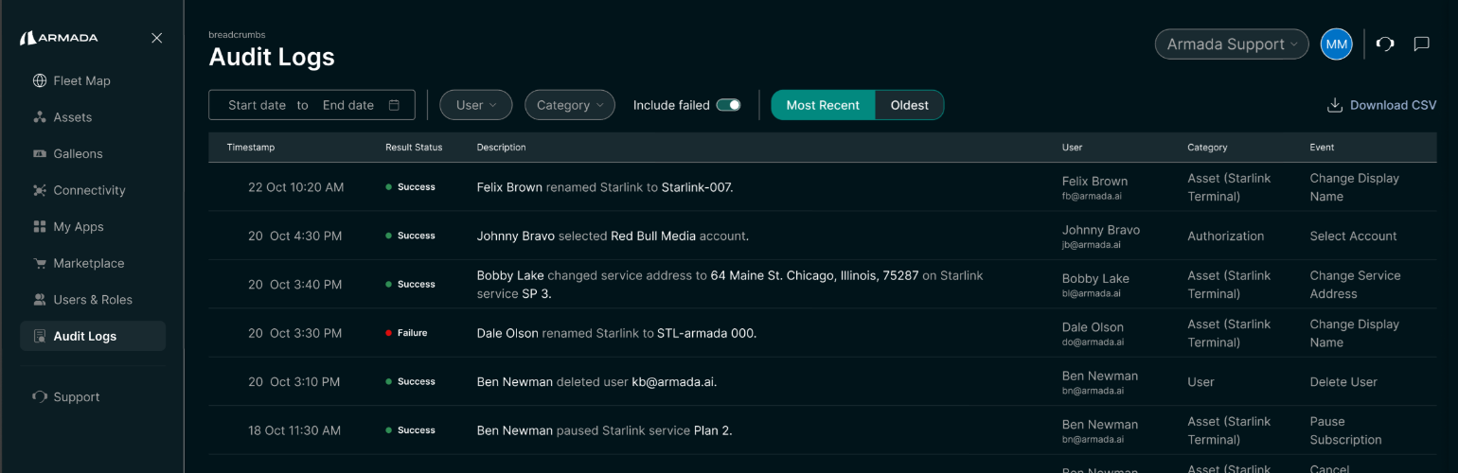

Users can customize the events displayed by specifying a time range, specific users, or event types. You also have the option to download the filtered results in CSV format. Clicking on a row provides additional details, including user attributes, account information, and request origin. If needed, the full message payload is accessible via the ‘View full request’ option in the Overview tab.

### Audit Logs FAQ

**Q: I don’t see the “Audit Logs” option or get an error when trying to access.** By default, users do not have access to audit logs because they are considered sensitive. Your Identity Admin needs to assign the new “Auditor” role to your user.

**Q: I want to find change events related to a specific asset or user; how do I do this?** While more sophisticated filter options for these use cases are planned in a future update, users can currently export rows using the “Download CSV” option and explore data offline.

**Q: Why don’t I see user logins as a type of event that is captured?** User login events are captured by our system but not displayed in this UI. The events shown in the Audit Logs experience are specific to a particular account. User logins are captured at the Organization layer and are not appropriate for the Account-level audit log report.

**Q: I want to see XYZ additional event type, but it’s not exposed in the “Category” filter.** In this initial release, we’ve audited the most requested events. However, we plan to expose additional event types (such as read actions, download audit log CSV, asset group management, etc.) in the future. Feel free to share your specific use case with us at feedback@armada.ai.

## Data Consumption Management

Armada provides individual terminal and fleet-wide consumption statistics to help organizations effectively observe and manage their data consumption.

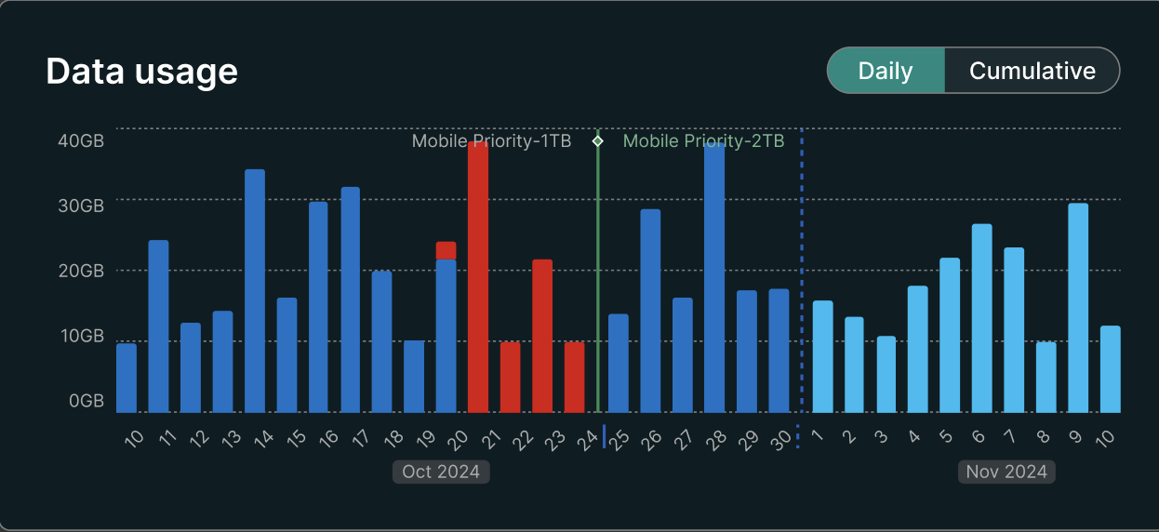

Armada can be configured to have terminals automatically opt-in for more priority data. Recommendations can be provided if terminals are not consuming their data cap and are thus not fully utilizing all the monthly data an enterprise is paying for.

### Pooled Data Plans

Starlink’s current plans and business model make it difficult and inefficient to purchase adequate data, because each terminal requires a line of service with its own individual data plan which can lead to excess money used to purchase data that will never be used.

To provide you with a more cost-effective and flexible solution, Armada offers a flexible and cost-effective pooled data solution for customers using multiple Starlink terminals. The Armada Connect Data Plan provides several key advantages:

* Share a single data pool across all your Starlink terminals for maximum flexibility
* Eliminate guesswork and need to purchase individual data plans per terminal
* Substantial cost savings compared to Starlink's individual terminal data plans
* Accommodate data usage surges and leverage 100% allocated bandwidth across terminals
* Simple, predictable monthly or annual pricing with one data plan to manage

### Managing Pooled Data Plans

Easily view your pooled data plans by navigating to the “Data Pools” section in the Armada Connect platform. Click on a data pool to view its details, usage statistics, remaining balance, and a list of service lines associated with it.

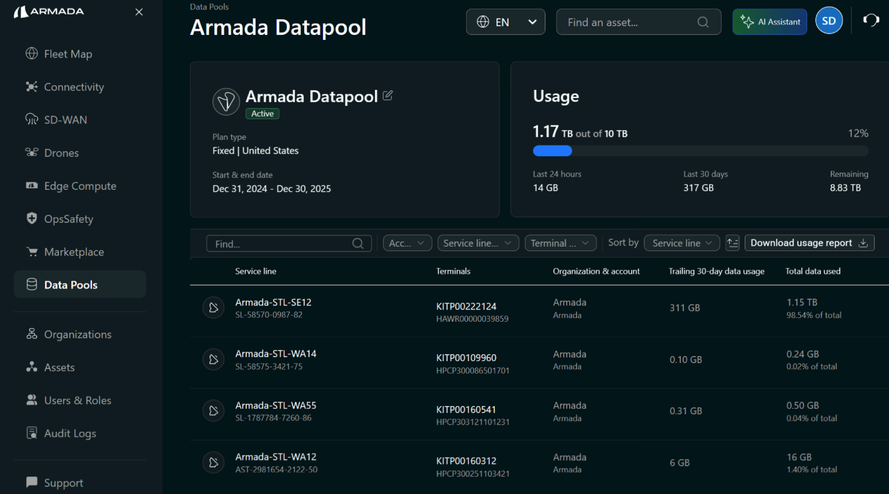

Click “Download usage report” to receive a detailed report from your data pool. The Excel file will contain a summary of your usage since the beginning of the data pooling period, as well as additional worksheets for detailed data usage, per day, per service line. Customers with multiple accounts, will see additional worksheets for each of their accounts.

### Case Study of an Existing US Based Customer

A client had 25 Starlink terminals and was using an average of 100 GB per month per terminal. Their setup included a mix of 1TB and 40GB fixed priority Starlink plans. By switching to Armada's Connect Data Plan, the customer achieved over 50% savings on their annual Starlink connectivity expenses.

By optimizing the connectivity solution with Armada's Connect Data Plan, the customer not only achieved substantial cost savings but also gained consistent priority bandwidth across all their terminals, streamlining their operations and enhancing their overall connectivity experience.

Armada provides customers a choice of pooled data plan tiers to meet their connectivity needs at a much lower cost than purchasing per-terminal plans. Below table lists the savings customers can achieve by using Armada Plans on Connect Platform:

* The equivalent Starlink pricing is calculated using uniform Starlink plans across 25 terminals using 40GB and 1TB plans

The Armada Connect plan provides fixed priority bandwidth by default. Combined with detailed usage reporting, near-limit alerts, and add-on capacity options, Connect ensures reliable, cost-effective satellite connectivity for your operations.

### Benefits of Armada Consumption Management

Armada’s consumption management and pooled data plan would provide the following:

* Significant cost savings
* Pooled data across all terminals
* Flexibility to accommodate usage spikes
* Simple, predictable monthly/annual cost

## Group based assets

Connect provides an easy way to manage assets through Groups. A user can create groups (providing name and description) and assign assets to groups. Connect also provides the flexibility to include an asset in any number of groups. In addition, the user has an ability to Filter by Groups on the Fleet map.

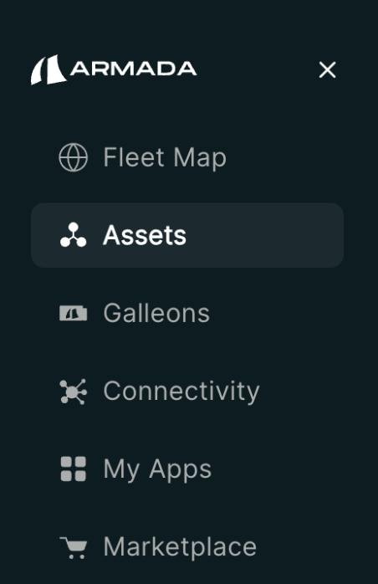

Access the Assets and Groups module through the Assets link on the navigation bar. This module includes a table view of all assets in your fleet and gives you the ability to create new Asset Groups and assign assets to them.

### Assets tab

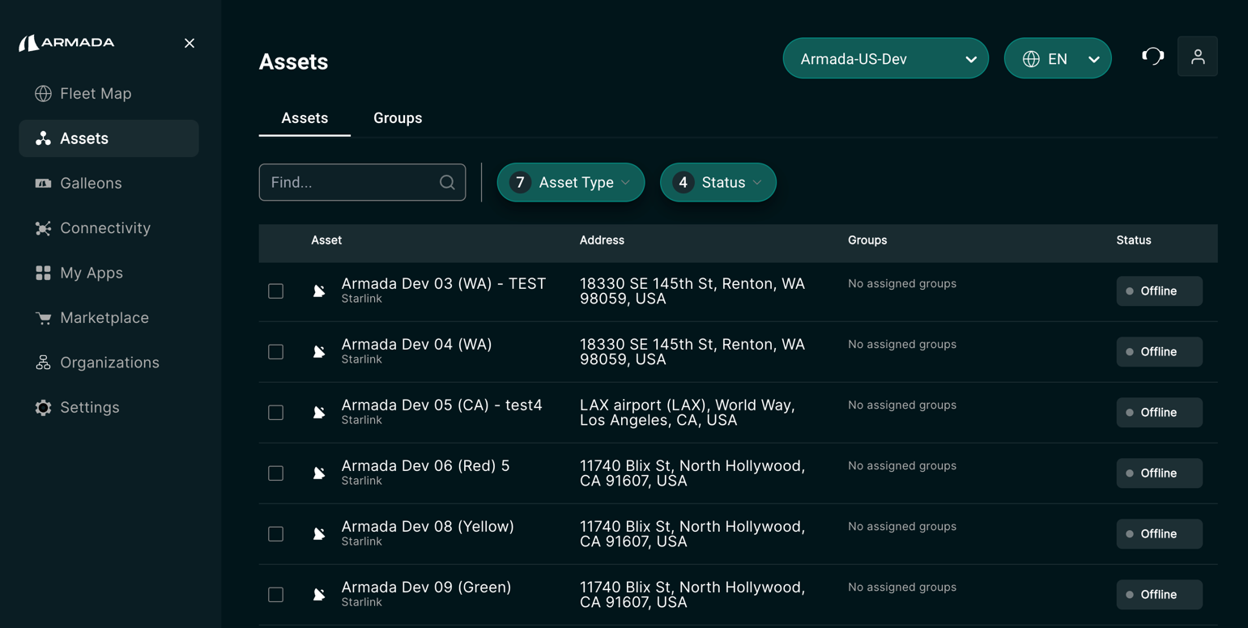

This tab shows you a list of all your connected assets. In the list view, you can see the display name, type of asset, address, health status, and a list of groups to which the asset belongs. You can search and filter this view to find the assets you are interested in managing in this module. Click on a row in this table to view additional details about the selected asset.

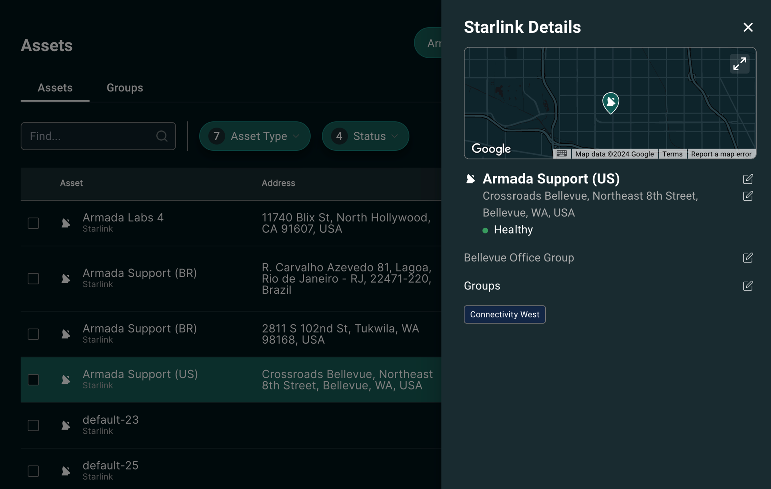

In this side-panel, you can view basic asset details, such as its display name, address, health status, description, and the groups to which it belongs. You can also edit these details from this view. Please note that for Starlink assets, editing the display name and the address will change the service line name and service line address of this Starlink asset.

Click on the pencil icon next to the Groups heading to add this asset to additional groups.

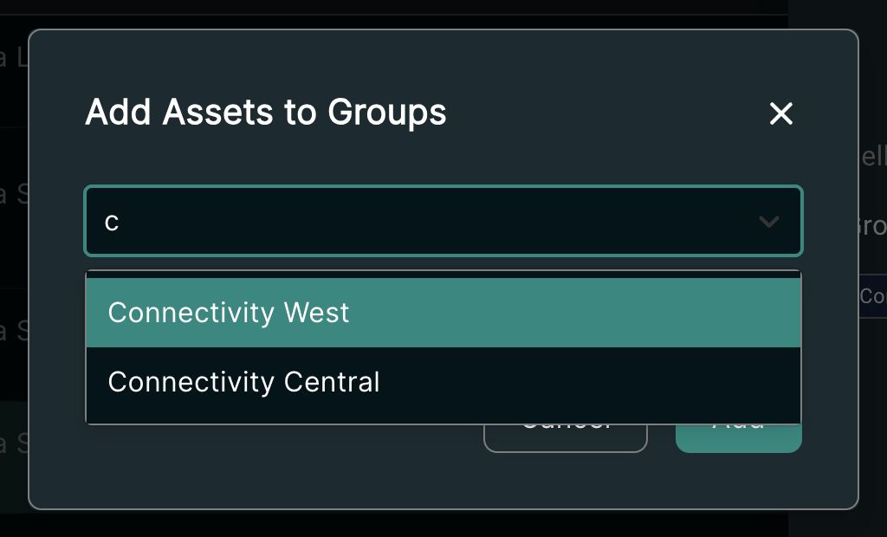

If you need to add multiple assets to one or more groups, select them on the list view, and then click on the "Add selected to a group" button on the top-right corner of the table.

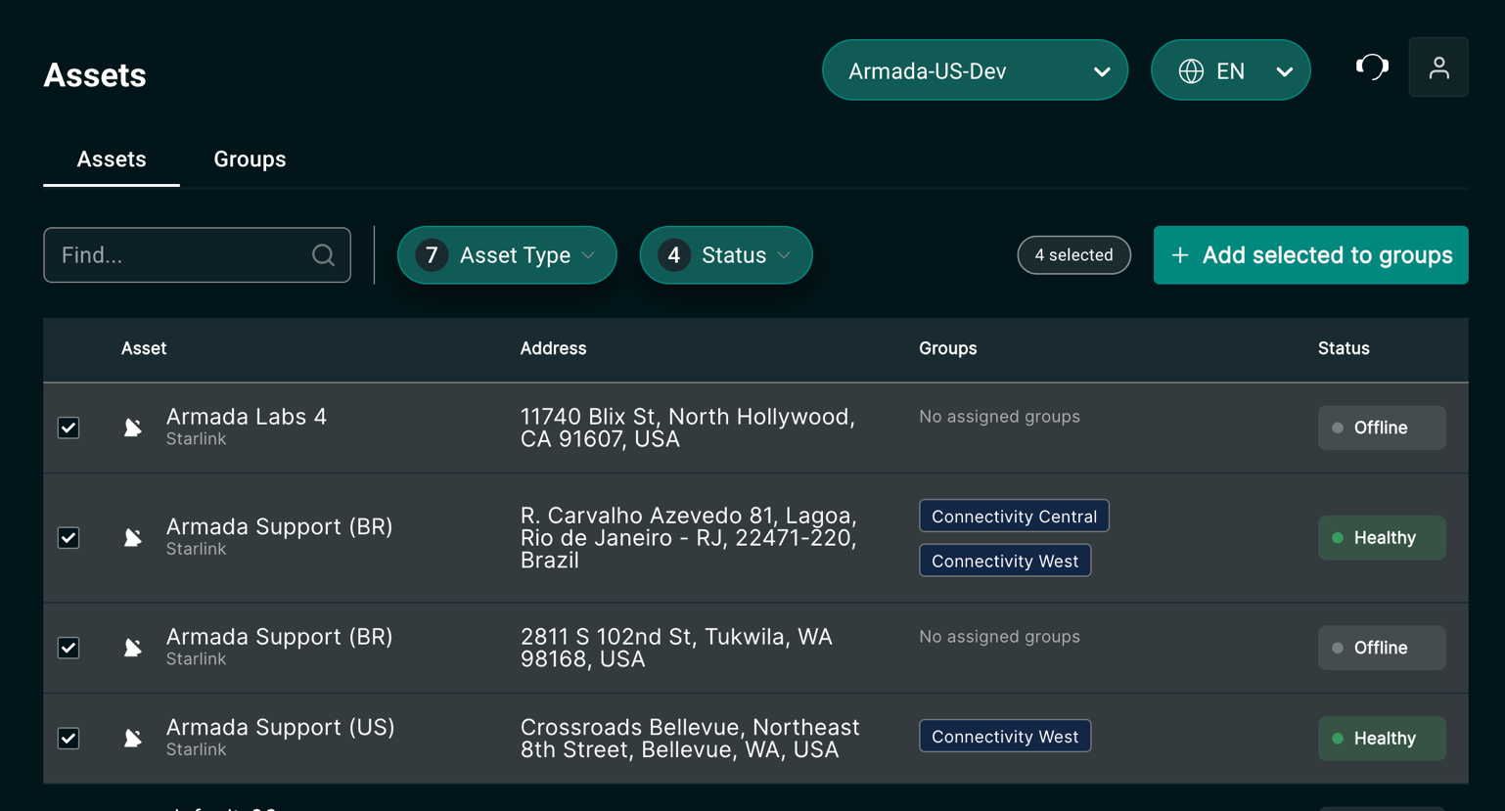

From the dialog, choose any number of groups that you'd like to add your selected assets to and click "Add".

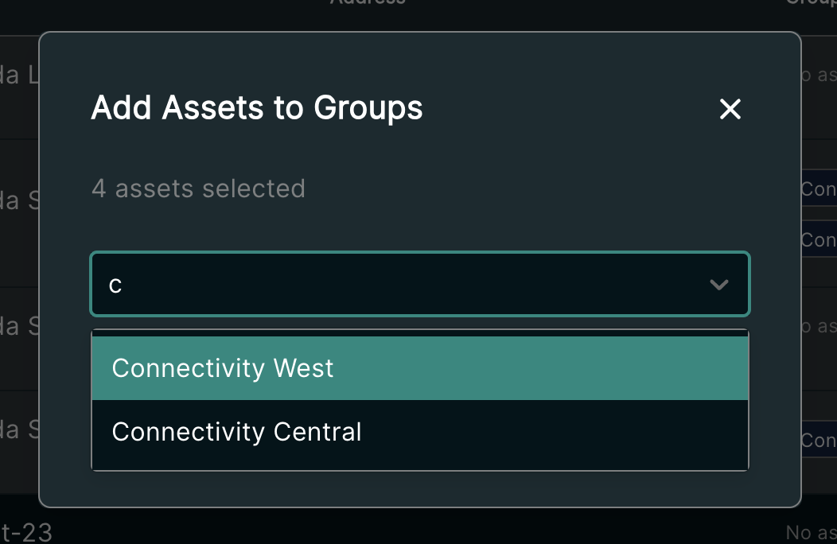

### Groups tab

Switch to the Groups tab to see a list of your groups. From here, you get a high-level view of any existing groups, including the name of the group as well as the number of healthy assets within it.

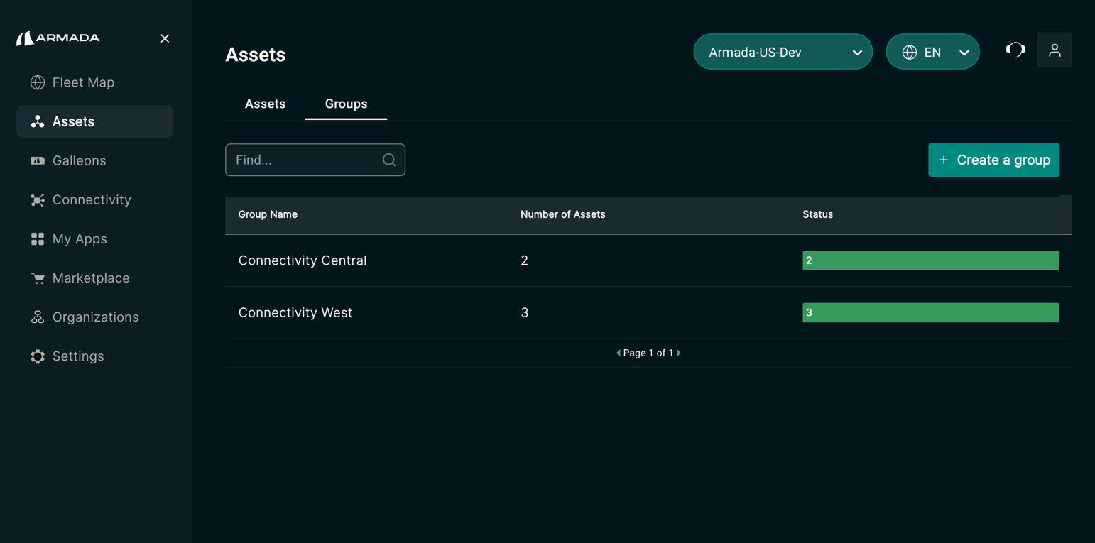

Click on a row on this table to view a list of assets in this group.

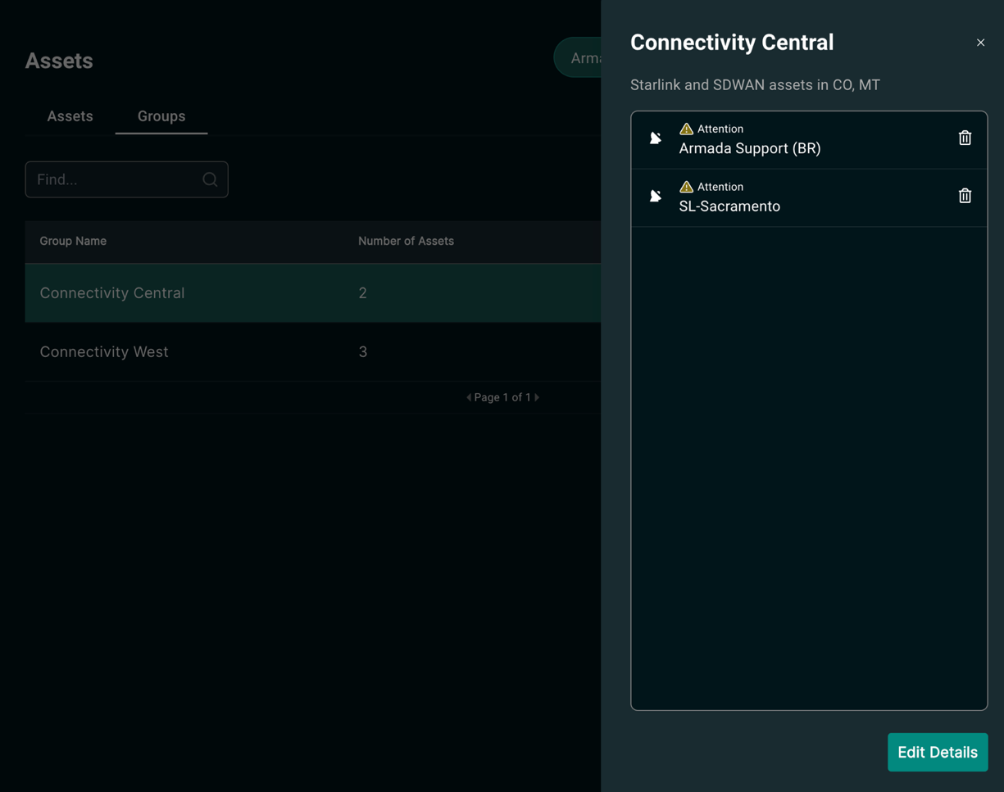

You can remove assets from this group by clicking on the Trash icon next to the name of the asset in the list.

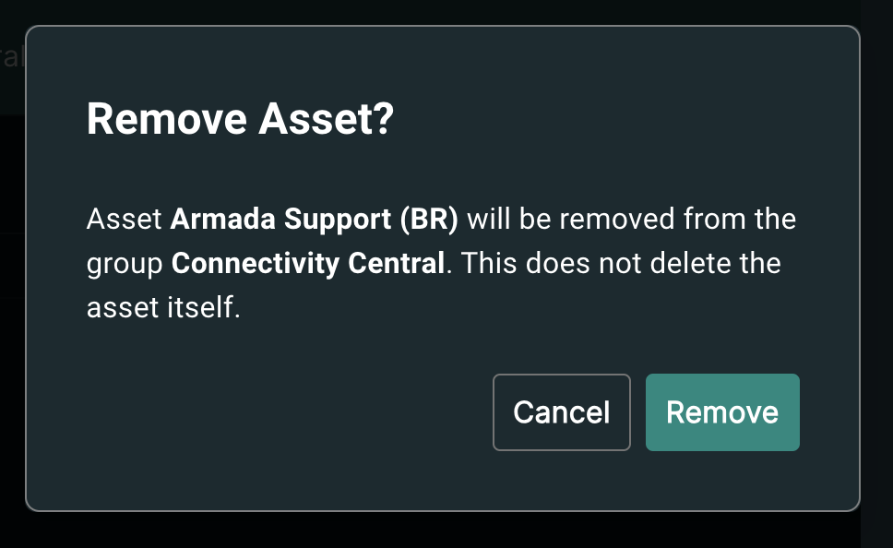

To edit the details of a group, including its name and description, click on "Edit Details" button in the group details side panel. In this dialog, you can update the details of the group or delete it entirely.

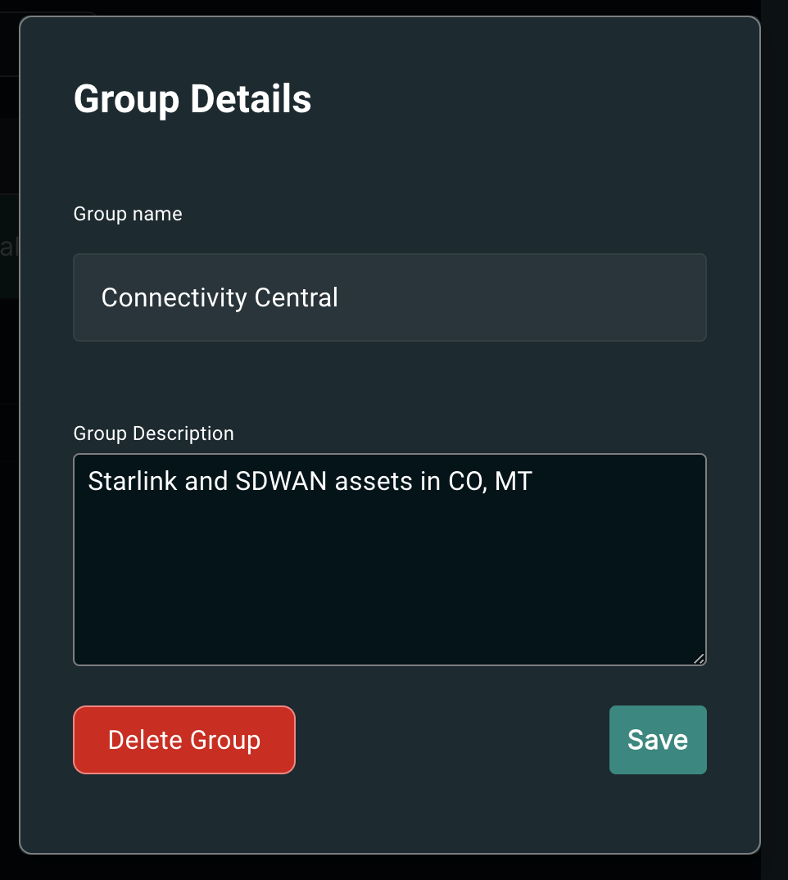

### Fleet Map - Filter by Groups

Once you have created your desired asset groups, and designated your assets to them, you can now filter your Fleet Map based on these groups. Choose one or more groups from the Groups filter to see assets in those groups. If no groups are selected through this filter, all assets will be displayed on the map, regardless of their group membership.

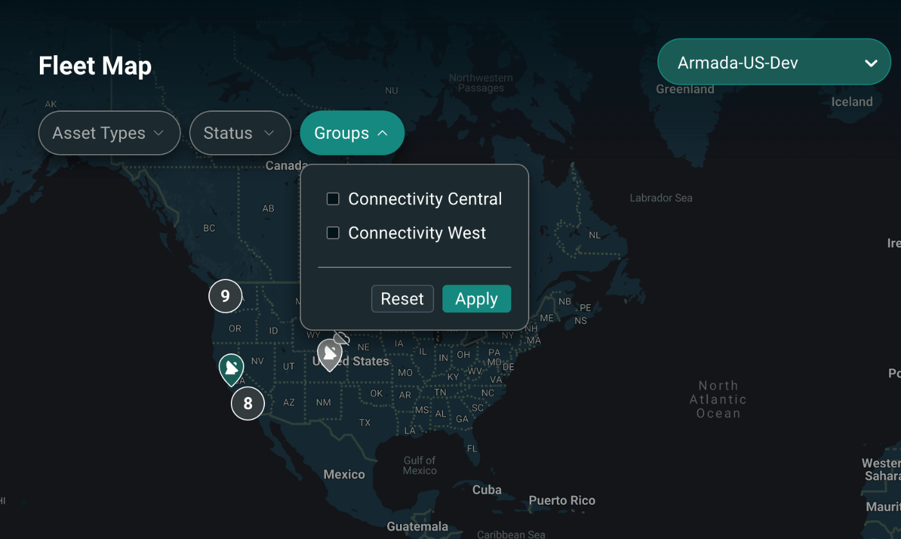

### Groups - FAQ

**Q: How many groups can I create? How many assets can I designate to my groups?**

* **Creating and Managing Groups:** You can create as many Groups as you'd like. Assets may belong to no, one, or more groups.

**Q: Where can I filter my assets by their group memberships?**

* **Filtering by Groups**: Currently you can only filter the Fleet Map view by Groups. We're working to bring the Groups filter to other parts of the Connect platform, including the Connectivity module.

**Q: Where can I see the groups that my assets belong to?**

* **Asset Group Memberships**: Currently you can only see an asset's group memberships in the "Assets" module. We're working to display assets' group memberships in other parts of the Connect platform, including on the Fleet Map and on the Asset Details view (e.g. Starlink Details view).

**Q: I see a description field. What's this for?**

* **Asset and Group Description**: While creating and managing groups and assets, you have the option to provide a free-form text description for your assets and groups. This text will be displayed in the Assets module. We are working toward displaying this text in other parts of the Connect platform, including on the Asset details view. In the future, we will make this free-form description searchable.

**Q: Can I control access for the Connect users in my organization at the asset group level?**

* **Access control**: We are working to enable Resource Based Access Control for Connect customers soon, but please be advised that access control is applied at the account level. You will not be able to control users' access to asset groups.

The user can also change an asset name, address, description from the Asset groups module.

### Asset Groups Benefit

Groups functionality simplifies the monitoring and management of Assets for users. Using this functionality users can create any number of groups and add specific assets to each of their groups. For e.g. a user might want to group assets by a certain geographic location, type of assets, or based on sub-organizations. In addition, Connect also makes it easy for the users to update Asset details in the Groups view.

### Asset Download

Export list of your assets as a CSV file from the Assets page. The download feature respects any search queries and filters you apply to the page. The CSV file includes general asset details (Name, Description, Address, Type, Groups) and specific fields for Starlink (ID, Serial, Kit, Service Line), Drones (Model, Serial), and Galleons (Name).

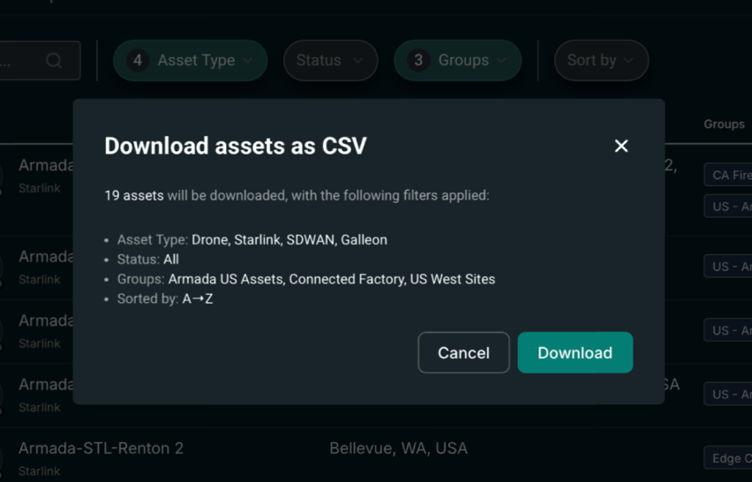

## Actionable Alerts and Observability

Armada provides alerting for Starlink hardware, service plans, connections, and firmware at both the individual terminal and fleet level, as opposed to Starlink’s traditional Dashboard which only provides alerting at the terminal level. Customers can view the operational status of each asset and receive actionable alerts to closely monitor and mitigate risks, such as accidents and costly repairs that threaten to disrupt their operations.

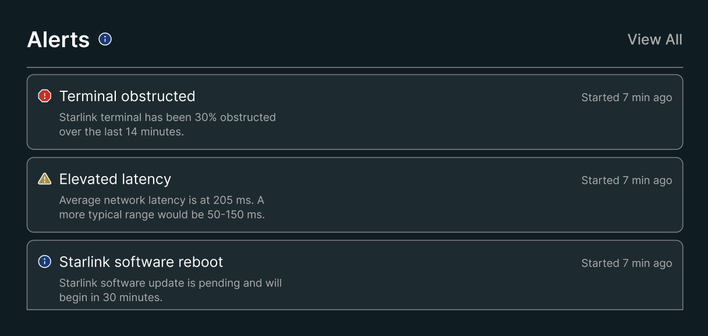

Figure 2‑: Fleet-wide Monitoring and Alerts

### Log Retention

While Starlink only logs 30 days' worth of data, **Commander Connect will store telemetry and log data for all connected terminals for 365 calendar days by default**, all viewable within the Connect portal, or exportable via .csv.

### Benefits of Commander Connect

Unlike Starlink’s software offering, Armada’s Connect provides an Enterprise ability to view all comprehensive asset information in near-real time and respond to alerts immediately. This will significantly reduce downtime, making it easier to manage a large distributed system of Starlink and IoT assets.

## Advanced Networking / Bonding

Armada’s deep networking expertise provides advanced configuration beyond what Starlink can provide out of the box. Connect can be integrated with leading SD-WAN solutions to provide capabilities such as bonding, which can process multiple individual Starlink connections into a single logical interface providing the following benefits:

* Increased Bandwidth: By combining multiple network connections, bonding can significantly increase the overall bandwidth available at customer locations.
* Fault Tolerance and Redundancy: If one of the physical interfaces fails or becomes disconnected, the other interfaces in the bond can pick up the slack, ensuring uninterrupted network connectivity.

## Artificial Intelligence-powered Tools

Armada develops its own proprietary Artificial Intelligence (AI) and Machine Learning (ML) models specifically trained and tuned to handle conversational support, analytics, and insights/foresights regarding an organization’s usage.

### AI Assistant - LLM Conversational Agent

The integrated AI Assistant in Commander is designed to enhance user workflows by offering intuitive interaction, live data insights, and asset management capabilities. It supports general information queries about the company, products, and security while also delivering account-specific metrics such as data usage for Starlink service plans. The assistant can provide live telemetry data, alert monitoring, and experimental health check support, empowering users to troubleshoot and monitor asset health effectively. It includes role-based awareness for tailored responses and session management for continuity during interactions, ensuring a streamlined user experience for both new and returning users.

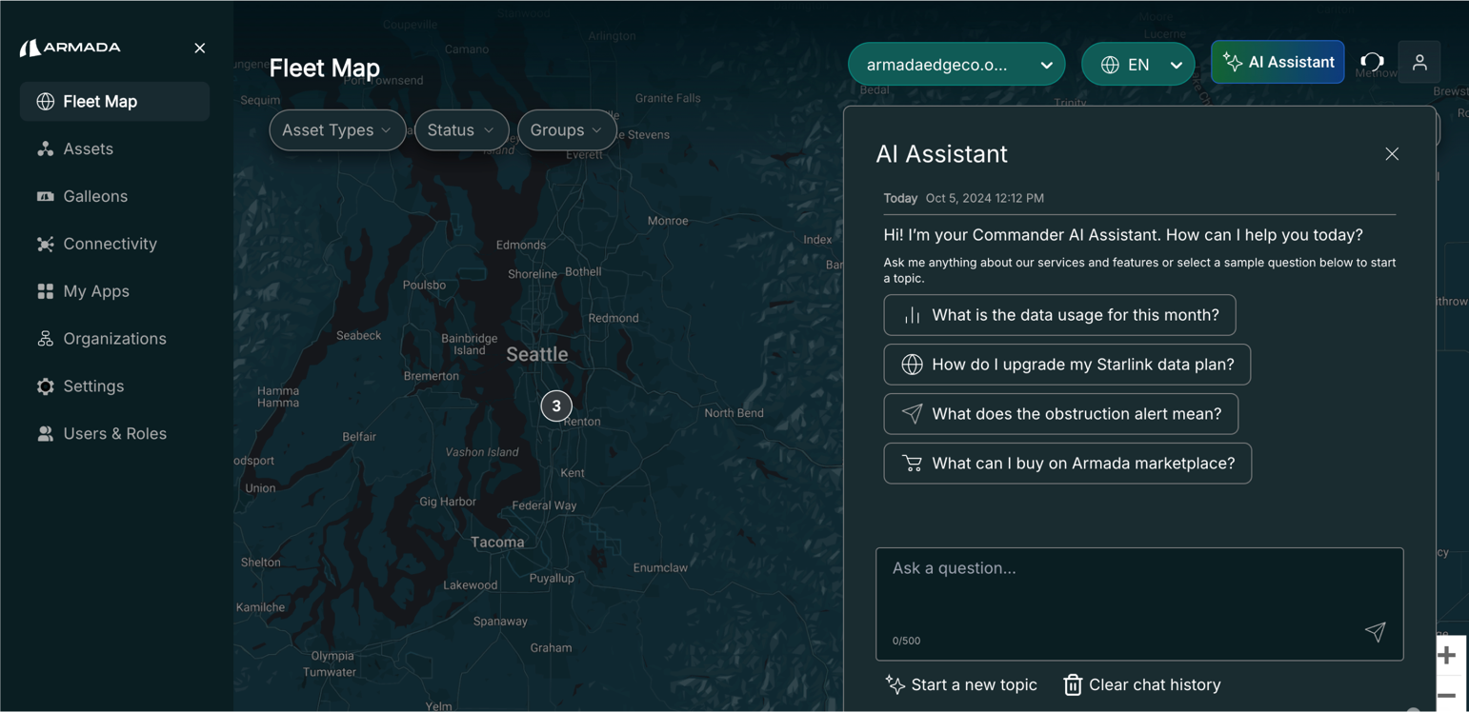

Figure 2‑3: AI Assistant

## Integrated Support

**End-to-End Support Experience**

Manage your support tickets directly in Commander. You can correspond with Armada support staff and track your requests and issues from start to resolution.

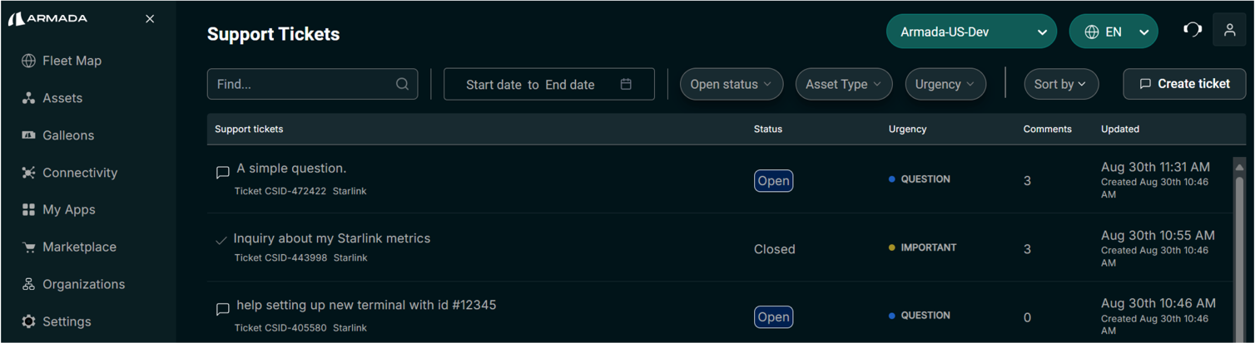

Figure: Commander View of Support Tickets Screen

**Conversation History**

Clicking on a ticket will display the conversation history with Armada support. You can:

* Reply to the agent
* Close the ticket
* Upload file attachments

When an Armada support agent replies to a ticket, the user will be notified via email with a direct link to view the reply in Commander.

**Support Ticket Information:**

* **Previous Tickets:** Past support tickets will not be transferred to the new system. You can continue to track any prior support requests via email.
* **Reopening Tickets:** If an issue is not fully resolved or reappears, you can reactivate any closed ticket by simply responding to it in Commander.
* **Sharing Tickets:** For security reasons, support tickets are only visible to the user who created them and the Armada support team.

## Armada Marketplace

Armada Marketplace is a platform for customers to procure and manage connected devices, focusing on satellite communications, enterprise-grade routers, IoT sensors, and edge computing servers.

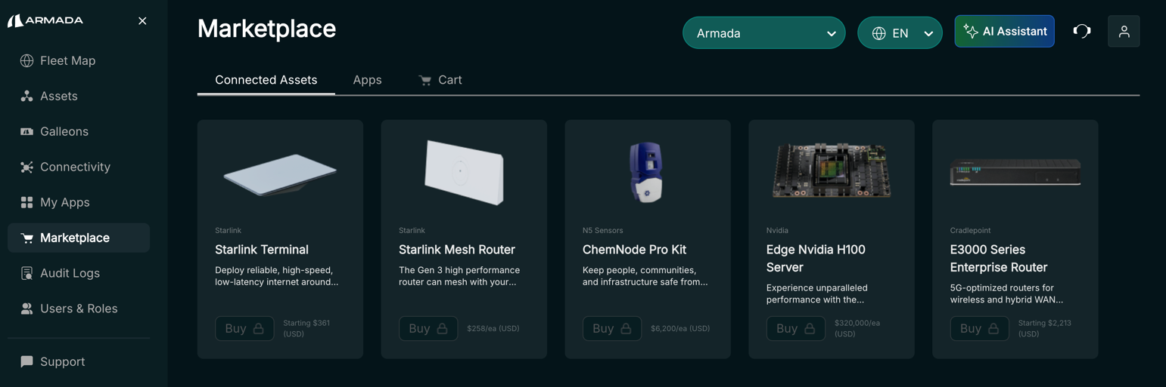

**Available Assets**

* Starlink Terminals and Data Plans
  + High-speed, low-latency satellite internet connectivity.
  + Various data plans to suit different usage needs.
  + Starlinks hardware variants including standard kit, flat high-performance kit, Mini, Enterprise, and Mesh router,
* Starlink Routers
  + Optimized routers for use with Starlink satellite internet service.
  + Designed for seamless integration with Starlink terminals.
* Cradlepoint Routers
  + Advanced wireless WAN solutions.
  + 4G LTE and 5G routers for reliable, secure connectivity.
  + Cloud-managed for easy deployment.
  + Enterprise-grade security.
* N5 Sensors
  + Advanced sensors for data collection and monitoring.
  + Enabling real-time insights across various applications.
* Edge NVIDIA H100 Servers
  + High-performance computing servers for edge deployments.
  + Powered by NVIDIA H100 GPUs for AI and machine learning applications.
* Data plans
  + Add a data plan to a pre-existing terminal

## Drones

### Skydio Drones

The Skydio drone integration in the Commander Connect platform allows users to onboard and manage their Skydio drones for enhanced situational awareness and operational efficiency. Users can view their entire drone inventory through a dedicated “Drones” module and on the Fleet Map, with visibility into flight status, battery levels, last pilot, and last known location. The platform also supports grouping drones with other asset types for better fleet management. Users can access detailed drone information, including flight history, media capture, and flight replays. This integration improves asset visibility and data utilization for operational insights, with future enhancements planned for live location tracking and streaming support

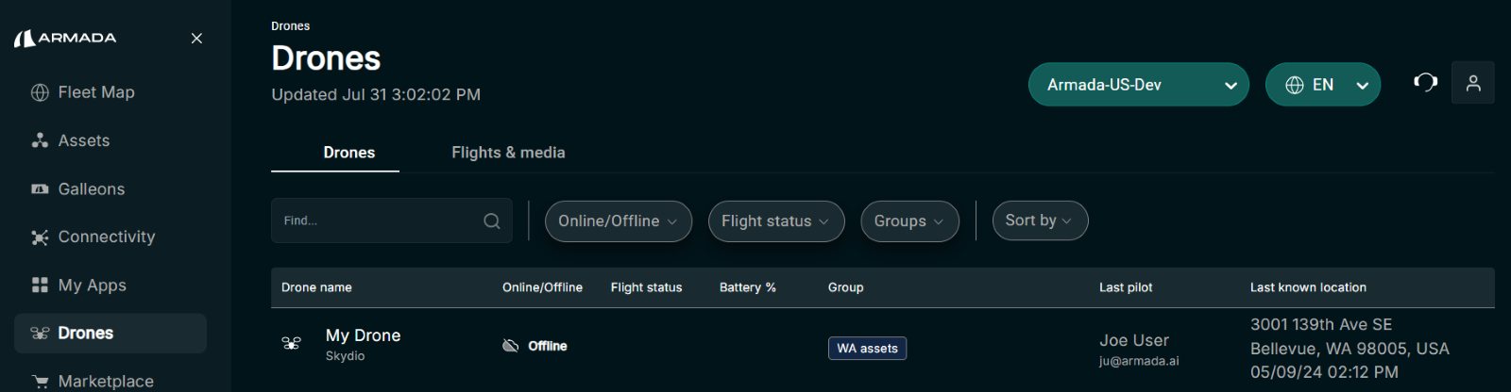

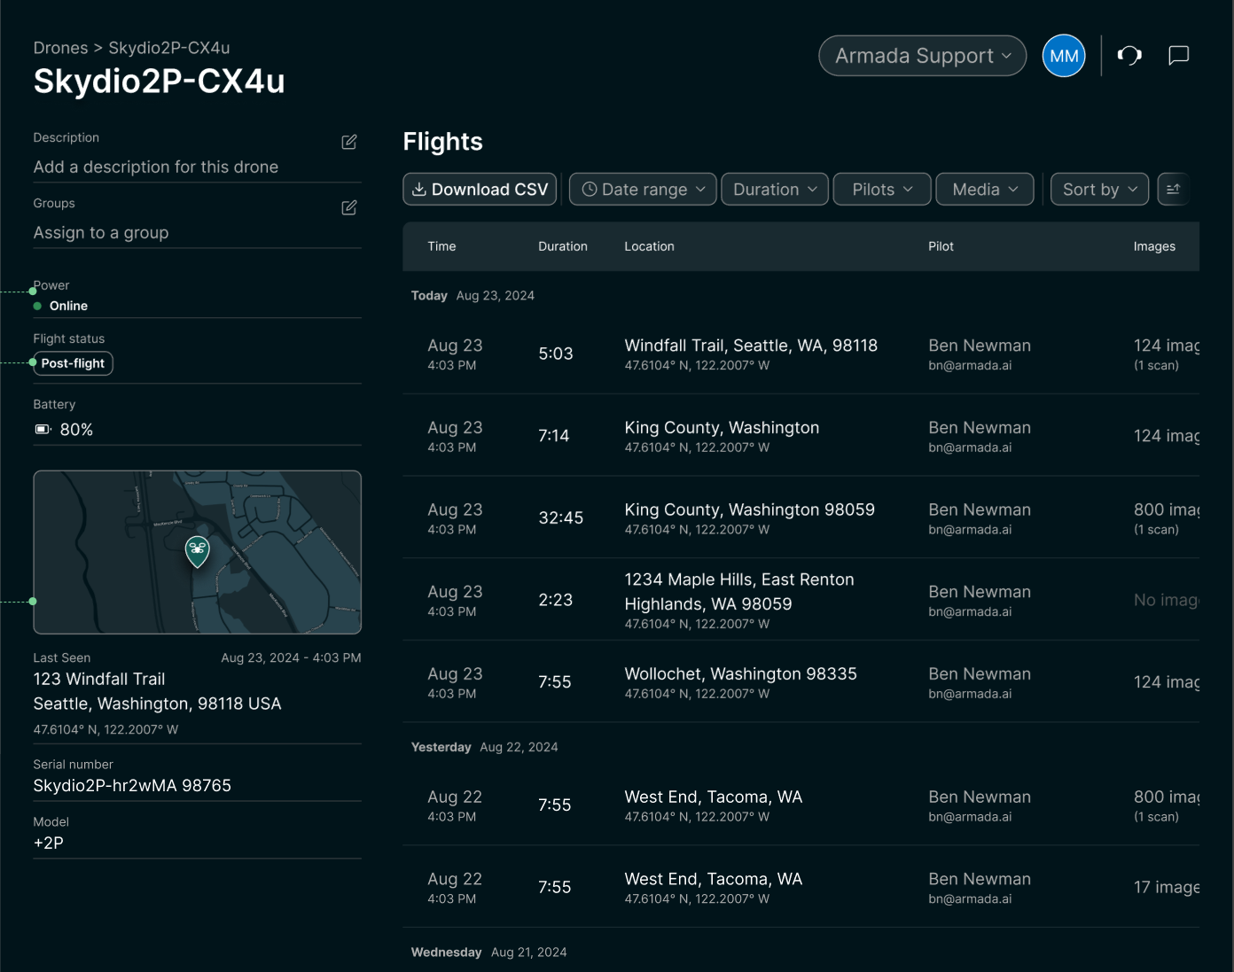  
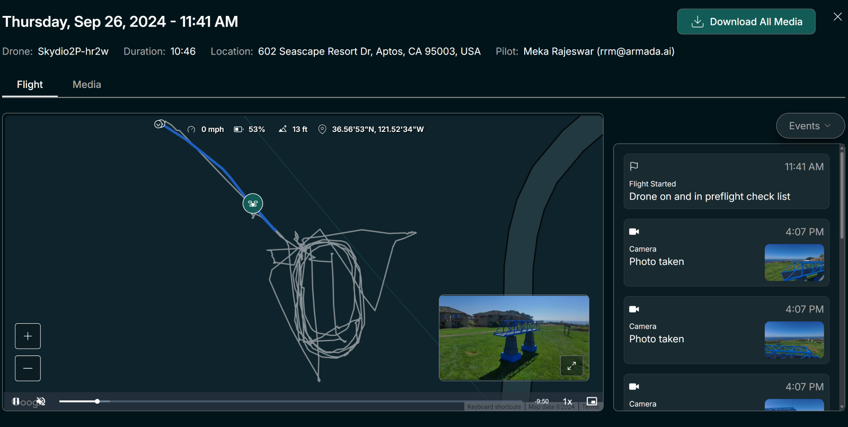

## SD-WAN

Commander Connect provides centralized management & operational insight for connected assets. Commander Connect introduces SD-WAN management capability to support IT and Operational teams for customers & managed service providers (MSP). SD-WAN Device Management in Connect platform offers centralized visibility and effortless configuration management for SD-WAN devices offered by different hardware vendors. In addition to existing assets, we are providing a single pane of glass to manage all the SD-WAN devices.

Users can navigate to SDWAN in the side panel and manage a list of SDWAN devices. Users could also view all their SDWAN devices through the fleet map. Users can then go into each of the device details from either the list view or the fleet map view.

This workflow obviates the need for network administrators to actively monitor each of the SDWAN devices in their network by going to the individual SDWAN vendor portal.

### Fleet Map view of SDWAN Devices

View SD-WAN devices on the fleet map, with location and connectivity details at a glance.

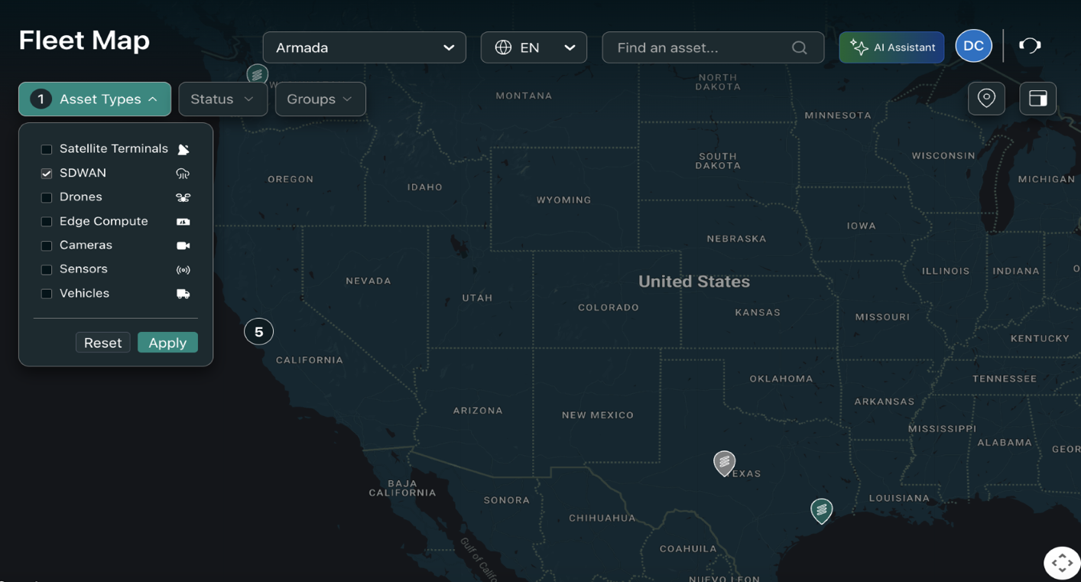

### List view of SDWAN Devices

Access the new ‘SD-WAN’ module through the main navigation menu to display the list of your SD-WAN devices. Find the devices by location. Sort and filter by status, vendor account, hardware type, and groups.

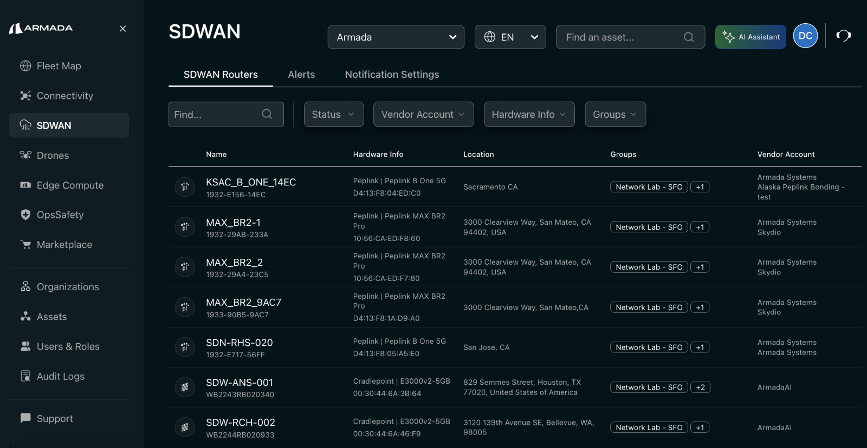

### SDWAN Device Details view

View device details such as the configuration, port layout, and WAN links—all within the device details page. Edit device description and groups.

